……………………. HIGH SCHOOL 2024-2025 EDUCATIONAL YEAR
9TH GRADERS’ 2ND TERM 2ND EXAM
Name - Surname : . . . . . . . . ………… Class : . . . . . . . Number : . . . . …

A) Read the paragraph and answer the questions. (20 P)
Göreme National Park is in Turkey. It is a World Heritage Site. It has beautiful fairy chimneys and cave houses. Many tourists visit it every year. People take photos and go hiking there. Göreme is important because of its history and nature. | 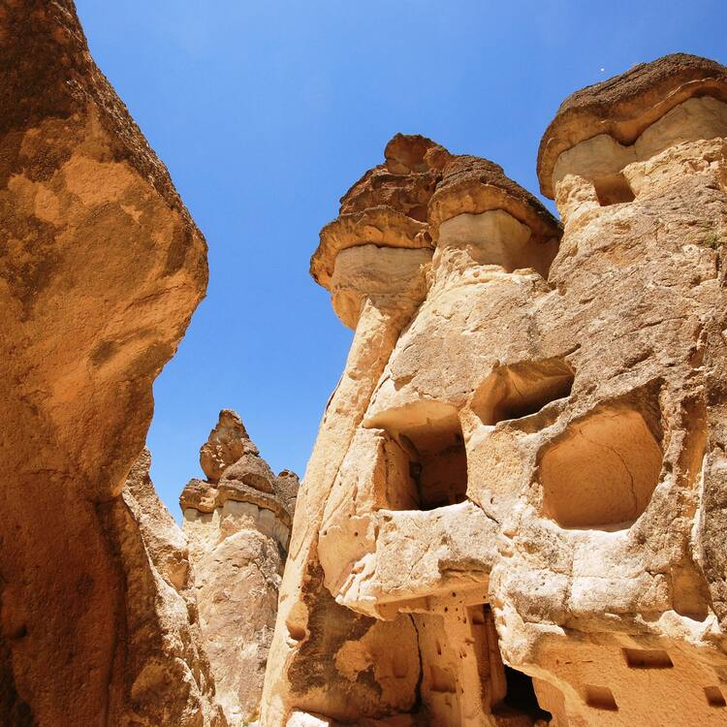
1. Where is Göreme National Park? _____________________________________________
2. What can people do in Göreme? ______________________________________________
3. Why is Göreme important? __________________________________________________
4. Is Göreme a World Heritage Site? _____________________________________________

B) Read the paragraph and answer the questions. (20 P)
Last night, I had a stomachache. I ate too much fast food. My mom gave me some medicine and I drank warm water. I felt better after a few hours. Now, I am more careful about what I eat. |  | 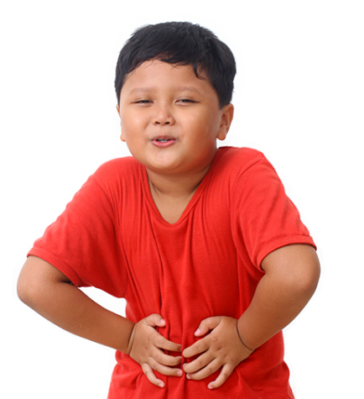
1. What was the health problem? ________________________________________________
2. What did the mom do? ______________________________________________________
C) Read the paragraph and answer the questions. (20 P)
 | We are organizing a birthday party for my best friend. The party will be on Saturday at 5 p.m. We will play games and eat cake. I made an invitation card and gave it to our friends. Everyone is excited about the party.
1. What kind of party is it? ___________________________________________________
2. When is the party? ________________________________________________________
3. What will they do at the party? ______________________________________________
4. Who made the invitation card? ______________________________________________

D) Read the text and answer the questions. (20 P)
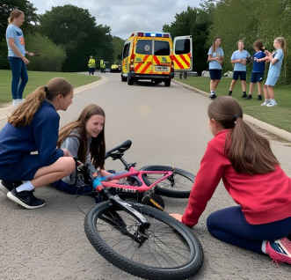 | Last weekend, Emily had a bad experience. She was at the park with her friends when she fell off her bike. She hurt her leg and couldn’t stand up. Her friends called an ambulance. The ambulance came in ten minutes. The doctors took her to the hospital. Now, she is at home and feeling better.
1. What happened to Emily? __________________________________________________
2. Where was she when the accident happened? ___________________________________
3. Who helped her? _________________________________________________________
4. What is the main idea of the text? ____________________________________________

E) Write a short paragraph about your future plans for a celebration. You can write about a birthday party, a graduation ceremony, or a surprise party. Use simple future tense (will / be going to). Write 4-5 sentences. (20 P)
__________________________________________________________________________
__________________________________________________________________________
__________________________________________________________________________
__________________________________________________________________________

✅ ANSWERS

PART A – World Heritage
- Göreme National Park is in Turkey.
- People can take photos and go hiking.
- Because of its history and nature.
- Yes, it is.

PART B – Emergency and Health Problems
- Stomachache.
- Too much fast food.
- She gave the writer medicine and warm water.
- Yes, the writer is more careful now.

PART C – Invitations and Celebrations
- A birthday party.
- On Saturday at 5 p.m.
- They will play games and eat cake.
- The writer made the invitation card.

PART D – Emergency and Health Problems
- She fell off her bike and hurt her leg.

- She was at the park.

- Her friends and the ambulance helped her.

- A girl had an accident and went to the hospital.

PART E - Invitations and Celebrations
Sample answer: I am going to have a birthday party next weekend. I will invite my best friends. We are going to eat cake and play games. I will take many photos. It is going to be a great day!



